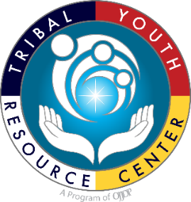
Youth Healing to Wellness Court
Fillable Strategic Planning Template
Tribal Youth Resource Center

Revised 5.12.25

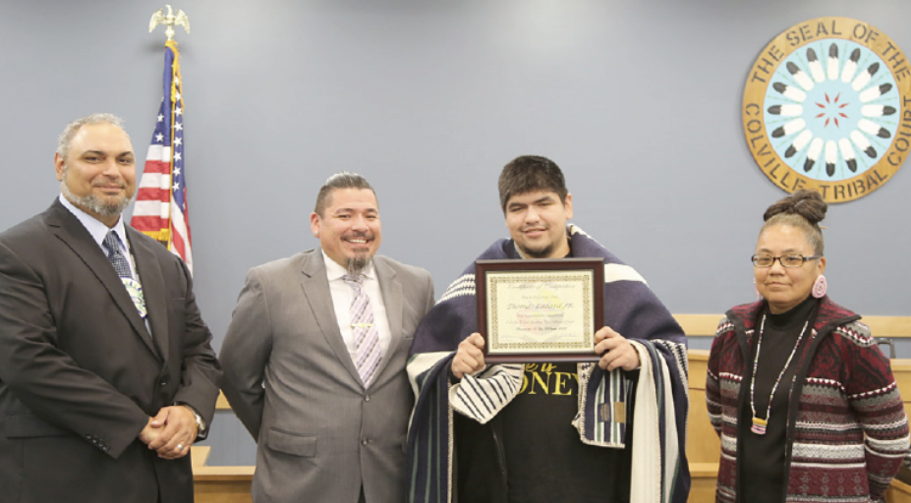
Source: Caudell, J. (2019, Nov 2). Colville tribal member Thomas Lezard completed the Colville Tribal Healing to Wellness Court. Tribal Tribune.
Grantee Name: ____________________
Fiscal Year Cohort: ____________________
TYRC YHWC TTA Specialist: ____________________
OJJDP Program Manager: ____________________

This project was supported by Grant #15PJDP-24-GK-02602-MUMU awarded by the Office of Juvenile Justice and Delinquency Prevention, Office of Justice Programs, U.S. Department of Justice.
The opinions, findings, and conclusions or recommendations expressed in this publication/program/exhibition are those of the author(s) and do not necessarily reflect those of the Department of Justice.
January 2025
*Adapted for Tribal Youth Healing to Wellness Courts from the National Council of Juvenile and Family Court Judges’ (NCJFCJ) “Starting a Juvenile Drug Court, A Planning Guide” (2014).

Table of Contents

Define the Problem | 3
Exercise 1- Arrest and Court Data | 3
Exercise 2- School Data (per school or within a school district) | 5
Exercise 3- Substance and Treatment Data | 7
Assemble the Planning Team (may also be the Operations Team) | 9
Exercise 4- YHWC Planning Team | 9
Exercise 5- YHWC Operations Team | 11
Define “Success” and Write a Purpose Statement | 13
Develop Goals for the YHWC | 16
Exercise 6- Our “Process” Goals Are: | 17
Exercise 7- Our “Outcome” Goals are: | 18
Map your Planning Process | 19
Figure 5- The Process of Planning | 19
Exercise 8- Complete your Planning Timeline | 20
Recruit a Steering Committee | 23
Exercise 9- Your Prospective YHWC Steering Committee Members | 23
Define a Selected Population and Set Eligibility Criteria | 24
Exercise 10- Which Tribal Youth Could be Best Serve by the YHWC? | 24
“Selected Population” | 25
Exercise 11- Our Eligibility Criteria | 26
Plan for Screening and Assessment for Entry and for Case Management | 27
Exercise 12- Reporting, referral, Screening, and Assessment Process | 27
Develop Your Phases | 30
Exercise 13- Our YHWC Phases | 30
Exercise 14- Reality Check | 31
Exercise 15- Multiple Tracks in Your Phases | 35
Design Incentives and Sanctions | 40
Exercise 16- Our Incentives | 40
Exercise 17- Our Sanctions | 44
Grant S.M.A.R.T Goal Guidance | 45
Year 1 Activities Action Plan | 50

Define the Problem

You will need to get a clear picture of how substance use is impacting Tribal youth, their families, the Tribal justice system, and your community. This will require gathering and reviewing certain types of data. Complete Exercises 1, 2, and 3 below to make informed decisions for your YHWC. Please allow several weeks to track down the available data.

Exercise 1- Arrest and Court Data
Arrest & Court Data  (arrests, complaints, petitions, violations of probation, etc.) | Year | Total Number | Comments
Alcohol Possession

Drug Possession

Trafficking (sales of small amounts)

Theft w/ alcohol or drug involvement

Other related to substance use
(e.g., driving under the influence)

Arrest & Court Data  (cont.) | Year  (cont.) | Total Number  (cont.) | Comments  (cont.)
Other offenses?
Violation of probation (for what reasons?)

Other probation violation offenses?

Exercise 2 – School Data (per school or within a school district)
School Absenteeism and Other Data | Year | Total Number | Comments
School/School District 1:

Number of Native or Tribal students who have missed 15 days of school in a year (unexcused)

Number of Native or Tribal students with incidents of serious offenses
Number of Native or Tribal students who have in-school suspensions
Number of Native or Tribal students who have out-of-school suspensions
Number of Native or Tribal students who have received an expulsion with or without educational services

School Absenteeism and Other Data  (cont.) | Year  (cont.) | Total Number  (cont.) | Comments  (cont.)
Number of Native or Tribal students who have been screened and referred for mental health issues

Name of School(s) and School District(s) and relevant counties:

Exercise 3 - Substance and Treatment Data
Substance Abuse Treatment Referrals for 202___

Total number of youths referred to treatment: |  | Number of available slots/spaces in adolescent-specific services for residential treatment:
Number of youths referred to treatment who have dropped out or failed: |  | Number of available slots/spaces in adolescent-specific services for outpatient treatment:
Number of youths referred to treatment who have not participated: |  | What Indian Health Services are available?
Number of youths who have been referred and have received treatment more than once: |  | What Tribal department/program services are available?
Other (describe): |  | What other or private services are available?

- Describe your issues with waiting lists, lack of resources and funding.

- Write a statement describing the problem in your community (cite the statistics).

- Describe how this problem with be impacted by your YHWC.

Assemble the Planning Team (may also be the Operations Team)

The YHWC planning team lays the groundwork for good working relationships among Tribal and other departments, programs, and service providers – so that later these entities will be able to provide a seamless continuum of services for youth and their families.

Exercise 4 – YHWC Planning Team
Agency or Organization | Representative | What they can contribute | Team Member (TM) or Additional Contributor (AC)
Agency or Organization  (cont.) | Representative  (cont.) | What they can contribute  (cont.) | Team Member (TM) or Additional Contributor (AC)  (cont.)

YHWC Operations Team (YHWC Team or “Core Team”)

The YHWC Operations team is made up of the line staff who will provide the actual services, as well as the coordinators, case managers/probation officers, school representatives, the clinicians in the treatment provider’s department, and in some cases, the attorneys assigned by their parent departments.

Exercise 5 – YHWC Operations Team (YHWC Team or “Core Team”)
Role | People Filling Role | Training and Orientation Needed
Judge |  | (example: key documents including purpose, goals, objectives, etc.)  (example: cross discipline training where a treatment representative conducts a workshop on levels of care, their services, and ethical obligations, etc.)
Prosecutor/Presenting Officer |  | (example: key documents including purpose, goals, objectives, etc.)  (example: cross discipline training where a treatment representative conducts a workshop on levels of care, their services, and ethical obligations, etc.)
Defense Attorneys/Advocates |  | (example: key documents including purpose, goals, objectives, etc.)
Coordinator |  | (example: cross discipline training on the Tribal juvenile court process and how youth may be reported, transferred, referred, or diverted from county or tribal court or county or tribal probation)  (example: cross discipline training on the role and ethics of defense attorneys)  (example: cross discipline training on the role and legal duties of prosecuting attorneys)
Treatment Representative |  | (example: key documents including purpose, goals, objectives, etc.)  (example: cross discipline training on how youth move through the Tribal juvenile court process)
Role  (cont.) | People Filling Role  (cont.) | Training and Orientation Needed  (cont.)
School Representative |  | (example: key documents including purpose, goals, objectives, etc.)  What is a YHWC?
Probation Representatives/  Case Manager |  | (example: key documents including purpose, goals, objectives, etc.)  What is a YHWC?
Elders and/or Culture Bearers |  | (example: key documents including purpose, goals, objectives, etc.)  What is a YHWC?

Define “Success” and Write a Purpose Statement

A purpose statement is a concise description of what you intend to do and why. Your purpose statement will help your team stay focused. Use the boxes to write and re-write your purpose statement using the samples provided.

What is our purpose?

Sample purpose statement

The purpose of the X Youth Healing to Wellness court is to reduce youth crime and alcohol and drug use …

Who is our broad selected population (later you will get more specific, for now you can be more general)?

Sample purpose statement

… youths with substance use/abuse and a moderate to high risk of reoffending, and their families …

How will we accomplish our purpose?

Sample purpose statement

… by providing both therapeutic and cultural interventions, with judicial supervision of …

Why are we doing this (what is the expected outcome)?

Sample purpose statement

The purpose of the X Youth Healing to Wellness court is to reduce Tribal youth crime, and alcohol and drug use by providing both therapeutic and cultural interventions, with judicial supervision of youths with substance use/abuse and a moderate to high risk of reoffending, and their families, thereby improving youth and family functioning and community safety.

Now combine your answers to the four questions above to create a purpose statement for your YHWC.
Our purpose is:

Develop Goals for the YHWC
A goal is simply a broad statement of something you want to accomplish. A process goal is something you plan to do, for example, “admit the first YHWC participant.” An outcome goal is an impact you want to make as a result of the things you do, for example “reduce substance use.” Use Exercise 6 and 7 below to define process and outcome goals.

Exercise 6 - Our “Process” Goals
1
2
3
4
5
6
7
8

Exercise 7 - Our “Outcome” Goals are:
1
2
3
4
5
6
7
8

Map your Planning Process

Below the figure, map out the additional steps you may need to develop your YHWC.

Figure 5- The Process of Planning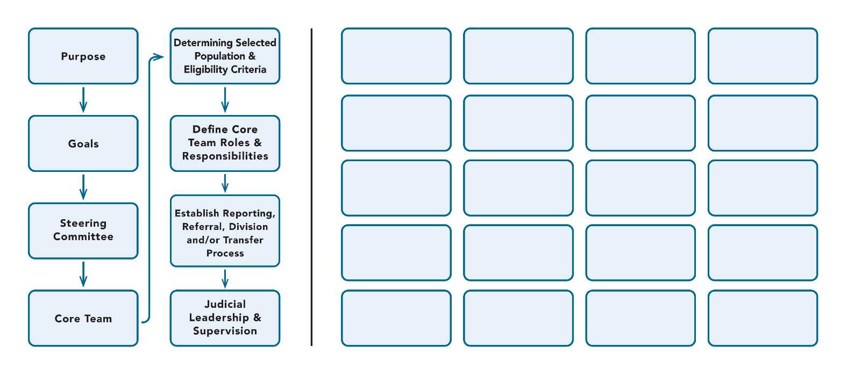

Make a list of your additional planned steps:

Planning Timeline

There are three options for scheduling your team’s planning meetings: (1) a few multi-day retreats where you can work through the entire process; (2) shorter meetings at a regular time each week or month; or (3) some combination of these two with regular meetings supplemented by an occasional retreat – or an initial retreat to get started, followed by regular weekly meetings.

Exercise 8 - Complete your Planning Timeline
 | Month 1 | Month 2 | Month 3 | Month 4 | Month 5
Meeting 1
Between Meetings
Meeting 2
Between Meetings

 | Month 6 | Month 7 | Month 8 | Month 9 | Month 10
Meeting 1
Between Meetings
 | Month 6 (Cont.) | Month 7 (Cont.) | Month 8 (Cont.) | Month 9 (Cont.) | Month 10 (Cont.)
Meeting 2

Between Meetings

 | Month 11 | Month 12
Meeting 1
Between Meetings
Meeting 2
Between Meetings |  | PILOT BEGINS

Recruit a Steering Committee

An effective steering committee is made up of key leaders in the community – people who can leverage resources, enlist the cooperation of other agencies, influence policymaking, and build community awareness of your work. If you get the buy-in of these leaders early-on and consult them throughout your planning process, they will be more invested in the final YHWC design and, once the court is operating, to advocate for its continuation.

Exercise 9 - Your Prospective YHWC Steering Committee Members
Prospective member, and the agency or organization they represent | Role on the steering committee (what would this person contribute?) | Contact Information | YHWC team member assigned to make contact

Define a Selected Population and Set Eligibility Criteria

Clearly define the population of youth that may be eligible for your YHWC in Exercise 10 below. The more clearly you define the population, the more likely it will be that you get appropriate reports, referrals and/or diversions. At the same time, a clearly defined selected population will make it more likely that the YHWC will maintain its focus on the community problems that were identified by the stakeholders at the outset of your planning process.

Exercise 10 – Which Tribal Youth Could be Best Served by the YHWC?
Age
(minimum age and maximum age of youth who can receive programming)

Court Status
(from informal investigation/intake/supervision (pre-hearing or pre-trial) to petitions being filed in court, to court disposition, probation, and/or diversion orders)
Gender

Severity of drug-use problem
(experimentation through addiction)

History of substance-abuse treatment
(from no prior treatment to extensive treatment)

Previous involvement in the Tribal or state justice system
(1st offense, more offenses)
Other

The “Selected Population” for our YHWC is:

Eligibility Criteria
Define your “eligibility criteria” – the criteria to be used by the YHWC team to screen each youth referred to the YHWC. List both “qualifiers” (the factors that must be present for a youth to enter your YHWC) and the “disqualifiers” (the factors that will automatically prohibit a youth from entering your YHWC). If your funder(s) restricts which youth you may serve, be sure to take these restrictions into account (e.g., no “violent offenders”). Select youth based on objective criteria whenever possible. Be careful that you do not have criteria that might rule out youth most in need of the YHWC.

Exercise 11 - Our Eligibility Criteria:
Eligibility Criteria for Our YHWC

Qualifiers | Disqualifiers

Plan for Screening and Assessment for Entry and for Case Management
For each step of the reporting, referral, screening, and assessment process, name the methods and the tools that will be used.

Exercise 12 - Reporting, Referral, Screening, and Assessment Process
Step | Purpose | Position/Department/Agency/  Entity Responsible  (fill in name & job title) | Tool  (select tool)
1. | Referral |  | YHWC eligibility criteria
2. | Legal Screening |  | YHWC eligibility criteria
3. | Clinical Screening – Substance Use and Mental Health |  | •Adolescent SASSI-A3  (Substance Abuse Subtle Screening Inventory)  •CRAFFT 2.1  •AUDIT  (Alcohol Use Disorders Identification Test)  •DAST-A  (Drug Abuse Screening Test for Adolescents)
4. | YHWC Admission |  | YHWC eligibility criteria
Step  (cont.) | Purpose  (cont.) | Position/Department/Agency/  Entity Responsible  (fill in name & job title)  (cont.) | Tool  (select tool)  (cont.)
5.A. | YHWC Case Plan Planning |  | RNR Tools:  •Correctional Offender Management Profiling for Alternative Sanctions (COMPAS)  •Federal Post Conviction Risk Assessment (PCRA)  •Inventory of Offender Risk, Needs, and Strengths (IORNS)  •Level of Service/Case Management Inventory (LS/CMI)  •Level of Service Inventory-Revised (LSI-R)  •Offender Profile Index (OPI)  •Offender Screening Tool (OST)  •Ohio Risk Assessment System (ORAS)  •Risk and Needs Triage (RANT)  •Risk Prediction Index (RPI)  •Static Risk and Offender Needs Guide (STRONG)  •Wisconsin Risk and Need Assessment Scale (WRN)
Step  (cont.) | Purpose  (cont.) | Position/Department/Agency/  Entity Responsible  (fill in name & job title)  (cont.) | Tool  (select tool)  (cont.)
5.B. | YHWC Care Plan, Wraparound Plan, or Wellness Plan Planning |  | •Child and Adolescent Needs and Strengths (CANS) screening and assessment tools  •Strengths, Needs, and Cultural Discovery (SNCD) Tool
6. | Culture Planning |  | •Dr. Cecil White Hat’s American Indian Traditional Family Roles Assessment Tool  •Anishinaabe Trauma Program, Anishinaabe Ishitwaawin  •Cultural Connectedness Scale CCS California Revised  •The Winnebago Tribe of Nebraska, Youth Crisis Intervention Center’s Cultural Identity Scale  •The Youth Council of Fresno American Indian Health Project’s Youth Personal Balance Tool (YPBT) (a wellness/goal setting tool)

Develop Your Phases

Your teams will determine what will happen during a youth’s time in the YHWC. What “phases” (sometimes called “steps,” “levels,” or “tiers) each youth will move through on the way to graduation.

Exercise 13 – Our YHWC Phases:
Phase: | Criteria for Movement to Next Phase

Reality Check

Map out the daily schedule of a family in your YHWC to ensure that your expectations are realistic. Remember to build in travel time, meals, and time with family.

Exercise 14 – Reality Check
TIME | Monday | Tuesday | Wednesday | Thursday | Friday | Saturday | Sunday
7:00-8:00 AM

8:00-9:00 AM

9:00-10:00 AM

10:00-11:00 AM

11:00 AM –
NOON

TIME  (cont.) | Monday  (cont.) | Tuesday  (cont.) | Wednesday  (cont.) | Thursday  (cont.) | Friday  (cont.) | Saturday  (cont.) | Sunday  (cont.)
NOON-1:00 PM

1:00-2:00 PM

2:00-3:00 PM

3:00-4:00 PM

4:00-5:00 PM

TIME  (cont.) | Monday  (cont.) | Tuesday  (cont.) | Wednesday  (cont.) | Thursday  (cont.) | Friday  (cont.) | Saturday  (cont.) | Sunday  (cont.)
5:00-6:00 PM

6:00-7:00 PM

7:00-8:00 PM

8:00-9:00 PM

9:00-10:00 PM
10:00-11:00 PM

TIME  (cont.) | Monday  (cont.) | Tuesday  (cont.) | Wednesday  (cont.) | Thursday  (cont.) | Friday  (cont.) | Saturday  (cont.) | Sunday  (cont.)
11:00 PM – MIDNIGHT

Multiple Tracks in Your Phases
Some Tribes seek to establish multiple tracks, with different sets of phases, for youth with differing levels/combinations of criminogenic risk and need. To determine which population of youth your YHWC team will serve, review the data you collected in exercises 1, 2, and 3 of this document. The purpose of this exercise is to assist the YHWC team in designing a dual or multi-track model (including different sets of phases) to match services and supervision to youth participants at different risk and need levels.

Exercise 15 – Checklist for Implementing Multiple Tracks (Different Sets of Phases)
Step # | Checklist | Next Steps
1 | Identify All Key Stakeholders  • Presiding YHWC judge  • Back-up YHWC judge  • Clerk staff  • Court administrator  • Bailiffs/court security  • Judicial assistant/clerk  • Information technology (IT) personnel  • Defense attorney/Public Defender/Local defense bar (entire bar)  • District Attorney/Prosecuting attorney’s office  Probation/Parole officers (tribal, district, regional, state, county, and city)  • Law enforcement  • Current treatment provider’s counselors, treatment provider supervisors/directors  • New or existing treatment providers and their supervisors and directors  •Tribal court  •Schools and School Attendance Review Boards  •Culture-bearers and Elders  • State court offices (State Court Administrator, State Drug/Treatment Court Coordinator, etc.)  • Community agencies (Employers, local businesses, local schools, churches, etc.)  • Local chapters of self-help/recovery groups  • Ancillary/wraparound services and programs:  - Providers of Pro-social Activities  - Job assistance agencies
Step # (cont.) | Checklist  (cont.) | Next Steps  (cont.)
- Housing assistance agencies
- Medical care and/or referral agencies
- Educational assistance agencies
- Daycare assistance agencies
- Transportation assistance
- Clothing assistance agencies
- Child welfare agency staff/decision makers
- Homeless shelters
- Transitional housing organizations/partners

2 | Observe a Treatment Court with an Established Multi-Track Model  • Identify a treatment court that has implemented a dual or multi-track model (as your TYRC TA provider)  •Arrange for key or all your YHWC team members to visit  •Interview team members from the court/program you are visiting  •Observe staff and court sessions
3 | Identify Individual(s) to Lead Planning and Implementation  •Judge (name)  •Other stakeholders (names)
4 | Develop a Formal Communication Process  •Develop a written communication protocol including what information is communicated, when and to whom
Step # (cont.) | Checklist  (cont.) | Next Steps  (cont.)
5 | Initiate Collaborative Planning  •Begin preliminary discussions about the implications for dual or multi-track model for each team member:  - Consider changes to job duties and whether this change will impact the team member’s department or agency;  - Consider suggestions from all team members about how to implement changes that will work for each respective team member and their department or agency; and  - Consider incentives, compensation, concessions that may need to be made in rearranging court schedules, staffing, or adding to team member duties.
6 | Identify Whom the Program Will Serve and What Services are Available  •Assess the risk and need levels of the potential program population to determine the numbers of individuals who might fall into each track  •Review existing court and probation programs to determine if there are options that already service individuals at different risk and need levels  •Perform community mapping to determine services available in your community or nearby (include telehealth options)  •Does your community have a health resource guide? (Health Services Resource Guides include a complete listing of local health care resources)  •Consider change to YHWC eligibility criteria based on the numbers of potential participants in your selected population, existing programs that may cover participants at various risk/need levels, and available services | Example: work with Tribal Probation and/or County Probation to identify youth populations that have been assessed as part of case planning in the past – to inform what tracks/sets of phases might be needed going forward
Step # (cont.) | Checklist  (cont.) | Next Steps  (cont.)
7 | •Are your services inclusive of all demographics in your community (e.g., boys, girls, Natives who are from other tribes, etc.)  •Are your services inclusive of all demographics in your community (e.g., boys, girls, Natives who are from other tribes, etc.)
8 | Understand the Fundamentals of Each Track  •Review the purpose of each track and the training (for staff) required for each  •Review how each track addresses each participants risks and needs  •Review the key requirements/services appropriate for each track
9 | Create Court Session Scheduled for Each Track  •What is the judge’s availability for staffing and court times?  •What is the availability of other team members?  •What is the availability of the court facilities (e.g., what times of day)?  •How long does the court session(s) need to be based on the number of participants expected in each track?  •How will you separate participants at different risk and need levels?  •Which days of the week will you see participants in each track, and which track will go first?  •How will you communicate the court schedule to team members and participants?
Step # (cont.) | Checklist  (cont.) | Next Steps  (cont.)
10 | Outline Supervision/Monitoring Requirements and Supervision Staff Assignments  •Educate supervision staff (e.g., probation) on the expectations of the program’s supervision requirements for participants at different risk and need levels in each track  •What kind of supervision assignments and responsibilities are feasible given existing caseloads for supervision?
11 | Develop a Plan of Treatment for Each Track  •Educate treatment providers about risk levels and the importance of keeping participants at different risk levels separate  •Ensure (or develop) a protocol for communicating participant risk level to the treatment providers  •Determine what training is needed for local treatment professionals  •Prepare the menu of treatment options for each track  •Establish formal agreement/contract between the court and treatment provider that included keeping participants at different risk and need levels separate, and other requirements and expectations for the treatment provider for each relevant track
12 | Develop Phases for Each Track  •Review sample documents for phase requirements for each track  •Develop phase requirements, including requirements to move from one phase to the next, for each track

Design Incentives and Sanctions
An effective system of incentives and sanctions will promote each youth’s ability to take responsibility and be accountable for his or her actions.

Exercise 16 – Our Incentives
Goal | Behaviors to Reinforce | Incentives or Reinforcers
- Reduce Substance Use | Example:  Attend treatment sessions at X three times per week from week two of Phase Two until advancement into Phase Three | Small Prizes:  - Credit for 1 hour of service learning  - Leave court early  - $5 gift card  - Extend curfew on 1 day for 1 hour  - Other?  Medium Prizes:  - Credit for 3 hours of service learning  - $10 gift card  - Extend curfew on 1 day for 2 hours  - Other?  Large Prizes:  - Credit for 5 hours of service learning  - $15 gift card  - Extend curfew on 1 day for 3 hours  - Other?
Goal  (cont.) | Behaviors to Reinforce  (cont.) | Incentives or Reinforcers  (cont.)
- Improve academic performance (reading skills, successful completion of courses, graduating from high school, completion of GED) | Example:  •Attending school/class  •Completing assignments  •Adhering to school rules  •Attending special interest classes  •Productively using study time  •Improving grades | Small Prizes:  - Credit for 1 hour of service learning  - Leave court early  - $5 gift card  - Extend curfew on 1 day for 1 hour  - Other?  Medium Prizes:  - Credit for 3 hours of service learning  - $10 gift card  - Extend curfew on 1 day for 2 hours  - Certificates  - Books  - Other?  Large Prizes:  - Recognition from the Judge  - Credit for 5 hours of service learning  - $15 gift card  - Extend curfew on 1 day for 3 hours  - Other?
Goal  (cont.) | Behaviors to Reinforce  (cont.) | Incentives or Reinforcers  (cont.)
- Participation in Pro-Social Activities | Example:  To maximize opportunities to participate in pro-social leisure activities: by participating in after school club one day per week from September 1st and November 30th. | Small Prizes:  - Credit for 1 hour of service learning  - Leave court early  - $5 gift card  - Extend curfew on 1 day for 1 hour  - Other?  Medium Prizes:  - Credit for 3 hours of service learning  - $10 gift card  - Extend curfew on 1 day for 2 hours  - Certificates  - Books  - Other?  Large Prizes:  - Recognition from the Judge  - Credit for 5 hours of service learning  - $15 gift card  - Extend curfew on 1 day for 3 hours  - Other?
Goal  (cont.) | Behaviors to Reinforce  (cont.) | Incentives or Reinforcers  (cont.)
- Improvement in Values, Beliefs, and Attitudes | Example:  To improve the youth’s identification with and sense of responsibility for community: by participating community, cultural, or skills-building activity on September 30th. | Small Prizes:  - Credit for 1 hour of service learning  - Leave court early  - $5 gift card  - Extend curfew on 1 day for 1 hour  - Other?  Medium Prizes:  - Credit for 3 hours of service learning  - $10 gift card  - Extend curfew on 1 day for 2 hours  - Certificates  - Books  - Other?  Large Prizes:  - Recognition from the Judge  - Credit for 5 hours of service learning  - $15 gift card  - Extend curfew on 1 day for 3 hours  - Other?

Exercise 17 – Our Sanctions
Goal | Behaviors to Discourage or Eliminate | Treatment Responses | YHWC Sanctions
Example:  Improve academic performance (reading skills, successful completion of courses, graduation from high school, GED) | Example:  •Skipping classes  •Violating rules at school  •Failing to complete assignments | Example:  •Tutoring  •Assessment  •Eyeglasses | Example:  •Increased YHWC appearances (at YHWC Status Hearings)  •Supervised daily study time  •Writing assignment  •Earlier curfew

Grant S.M.A.R.T. Goal Guidance
Your Tribe already has written goals and objectives in the approved and funded grant narrative. Please note your team will use those as you move through the S.M.A.R.T. process. This is an opportunity to clarify your written, short-term (annual), project goals. Your goals may already be clear. If you develop new or different goals, you will need to visit with your OJJDP Program Manager if there are any significant changes in scope to your project.
Objectives are focused, measurable, and support the long-range goals (at the end of your 5-year award) that your team has set forth. It is important to set out clear objectives to support your goals. Think of objectives as the smaller steps that are needed to reach each goal. Setting clear objectives can support the team as you gauge timelines and identify actions needed to make progress.

Setting S.M.A.R.T. Goals
A SMART goal is defined as one that is specific, measurable, achievable, realistic and time bound. Below is a definition of each of the SMART goal criteria.

Grant S.M.A.R.T. Goals:

Project Name: [Insert Name of YHWC]

General Project Description:

Purpose Statement:

Goal 1: 1Transcribe goals from your narrative, previous unattained goals, or new goals you have for this round of funding.

Project Goal 1: Enter your new SMART goal here

Objectives to support reaching project goal.

Objective 2a

Objective 2b

Objective 2c

Goal 2: Transcribe goals from your narrative, previous unattained goals, or new goals you have for this round of funding.

Project Goal 2: Enter your new SMART goal here

Objectives to support reaching project goal.

Objective 2a

Objective 2b

Objective 2c

Goal 3: Transcribe goals from your narrative, previous unattained goals, or new goals you have for this round of funding.

Project Goal 3: Enter your new SMART goal here

Objectives to support reaching project goal.

Objective 3a

Objective 3b

Objective 3c

Year 1 Activities Action Plan

There are a number of activities that may contribute to the overall development of your YHWC. The activities listed below are suggested activities. Your YHWC team, with guidance from your steering committee, should determine the specific activities, tasks and timelines.
Suggested Year 1 Activities Action Plan

Suggested Activities/Benchmark | Tasks to Meet Benchmark | Lead/Team Responsible | Status
1. Assemble the YHWC planning team/core team
2. Review existing data and define the problem

3. Draft the YHWC Purpose Statement

4. Draft the YHWC Goals

5. Map YHWC Planning Process

Suggested Activities/Benchmark  (cont.) | Tasks to Meet Benchmark  (cont.) | Lead/Team Responsible  (cont.) | Status  (cont.)
6. Assemble YHWC steering committee

7. Gain leadership and community support

8. Hire staff and identify the YHWC core team members and define their roles and responsibilities

9. Determine the YHWC Selected Population

10. Determine the YHWC Eligibility Criteria

11. Develop the YHWC Entry Process (reporting, referral, diversion, and/or transfer)
12. Develop the YHWC Screening and Assessment Process

Suggested Activities/Benchmark  (cont.) | Tasks to Meet Benchmark  (cont.) | Lead/Team Responsible  (cont.) | Status  (cont.)
13. Develop YHWC Alcohol and Drug Testing Protocol

14. Develop YHWC Phase Structure

15. Design YHWC Incentives and Sanctions Structure and Protocols

16. Determine Case Management Approach and Supervision Processes

17. Select Treatment Providers

18. Negotiate and enter into service provider partnerships (MOAs/MOUs/Letter Agreements), and negotiate and execute contracts
19. Establish process for case staffing and reporting

Suggested Activities/Benchmark  (cont.) | Tasks to Meet Benchmark  (cont.) | Lead/Team Responsible  (cont.) | Status  (cont.)
20. Establish process for YHWC Status Hearings and for acknowledging participant progress

21. Develop Forms for Consent and Waiver Re: Participant Confidentiality

22. Develop/reform Tribal law to support Tribal Juvenile Court and YHWC functions

23. Develop the YHWC Policies and Procedures Manual

24. Develop the YHWC Participant Handbook

25. Develop the YHWC data management system and process

26. Participate in supportive training and technical assistance

Suggested Activities/Benchmark  (cont.) | Tasks to Meet Benchmark  (cont.) | Lead/Team Responsible  (cont.) | Status  (cont.)
27. Submit all required OJJDP Reports

